Eritrea

## Population Data

The data set shows the political stability estimate of the country each year.

## # A tibble: 23 x 5  
## country iso3c date population popCategory5  
## <chr> <chr> <dbl> <dbl> <chr>   
## 1 Eritrea ERI 1996 2196464 very small   
## 2 Eritrea ERI 1997 2195179 very small   
## 3 Eritrea ERI 1998 2206432 very small   
## 4 Eritrea ERI 1999 2237405 very small   
## 5 Eritrea ERI 2000 2292416 very small   
## 6 Eritrea ERI 2001 2374722 very small   
## 7 Eritrea ERI 2002 2481058 very small   
## 8 Eritrea ERI 2003 2600973 very small   
## 9 Eritrea ERI 2004 2719803 very small   
## 10 Eritrea ERI 2005 2826659 very small   
## 11 Eritrea ERI 2006 2918205 very small   
## 12 Eritrea ERI 2007 2996536 very small   
## 13 Eritrea ERI 2008 3062779 very small   
## 14 Eritrea ERI 2009 3119920 very small   
## 15 Eritrea ERI 2010 3170435 very small   
## 16 Eritrea ERI 2011 3213972 very small   
## 17 Eritrea ERI 2012 NA <NA>   
## 18 Eritrea ERI 2013 NA <NA>   
## 19 Eritrea ERI 2014 NA <NA>   
## 20 Eritrea ERI 2015 NA <NA>   
## 21 Eritrea ERI 2016 NA <NA>   
## 22 Eritrea ERI 2017 NA <NA>   
## 23 Eritrea ERI 2018 NA <NA>

# Population growth data

## # A tibble: 23 x 5  
## country iso3c date popGrowth popGrowthCat5   
## <chr> <chr> <dbl> <dbl> <chr>   
## 1 Eritrea ERI 1996 -0.353 declining   
## 2 Eritrea ERI 1997 -0.0585 declining   
## 3 Eritrea ERI 1998 0.511 slow growth rate   
## 4 Eritrea ERI 1999 1.39 slow growth rate   
## 5 Eritrea ERI 2000 2.43 moderate growth rate  
## 6 Eritrea ERI 2001 3.53 high growth rate   
## 7 Eritrea ERI 2002 4.38 high growth rate   
## 8 Eritrea ERI 2003 4.72 high growth rate   
## 9 Eritrea ERI 2004 4.47 high growth rate   
## 10 Eritrea ERI 2005 3.85 high growth rate   
## 11 Eritrea ERI 2006 3.19 high growth rate   
## 12 Eritrea ERI 2007 2.65 high growth rate   
## 13 Eritrea ERI 2008 2.19 moderate growth rate  
## 14 Eritrea ERI 2009 1.85 moderate growth rate  
## 15 Eritrea ERI 2010 1.61 moderate growth rate  
## 16 Eritrea ERI 2011 1.36 slow growth rate   
## 17 Eritrea ERI 2012 NA <NA>   
## 18 Eritrea ERI 2013 NA <NA>   
## 19 Eritrea ERI 2014 NA <NA>   
## 20 Eritrea ERI 2015 NA <NA>   
## 21 Eritrea ERI 2016 NA <NA>   
## 22 Eritrea ERI 2017 NA <NA>   
## 23 Eritrea ERI 2018 NA <NA>

## Population trend

The plot shows the population trend of the country.

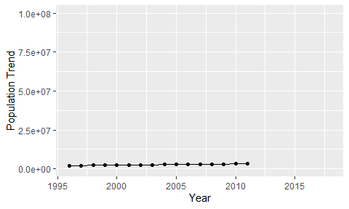

Political Stability Trend

# Population growth trend

The plot shows the population growth rate trend of the country.

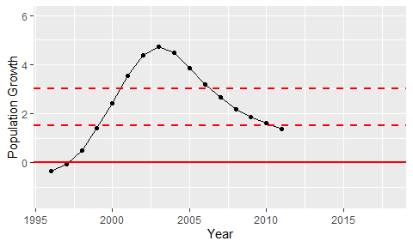

Population Growth Trend